Automatic Coil Winding Machine

Coils are used for winding to make motors, transformers and other similar applications. But the winding process is a tricky process as it requires accuracy and becomes a very laborious process if done manually. Well here we propose an automatic coil winding machine that can automate this process completely.
The 2 major factors that are necessary are the no of turns needed and the winding tightness. Loosely winded coils do not perform as intended hence this is also an important factor.

The Auto oil winder machine automates this task using a dual motor arrangement. The system makes use of a DC motor and s stepper motor to drive this system. The DC motor is used to drive the coiling wheel while the stepper motor is used to drive the toroid core to be winded.

The system allows user to input the number of turns along with outer dimension of the core along with the amount of core to be winded. This data is now used by the system to achieve desired output.

The rotating wheel driven by DC motor is integrated with IR Based RPM sensors to record the number of turns. This allows the system to ensure number of completed coil turns on the core. A stepper motor is used to accurately turn the core at 90° perpendicular motion to the rotation direction of the coiling wheel.

The core is driven by a stepper motor roller and we use 2 more rollers to hold and rotate the core ring in the machine. Thus the system provides a fully automated mechanism for coil winding using motorized arrangement.

Components:
- Atmega 328 Controller
- IR Sensor
- DC Motor
- Stepper Motor
- Dummy Rollers
- Belt Pulley
- LCD Display
- Power Port & DC power Adapter
- Resistors Capacitors
- Diodes & transistors
- Buttons & Switches
- Electrical & Wirings
- PCB Board
- Base frame
- Supporting Rods
- Connectors
- Screws and Fittings

Applications:
- Transformer Winding

Advantages:
- Fully Automatic Winding
- High Accuracy Winding
- High Speed Winding
- No Human Efforts Needed

Disadvantages:
- It is not battery powered

Block Diagram

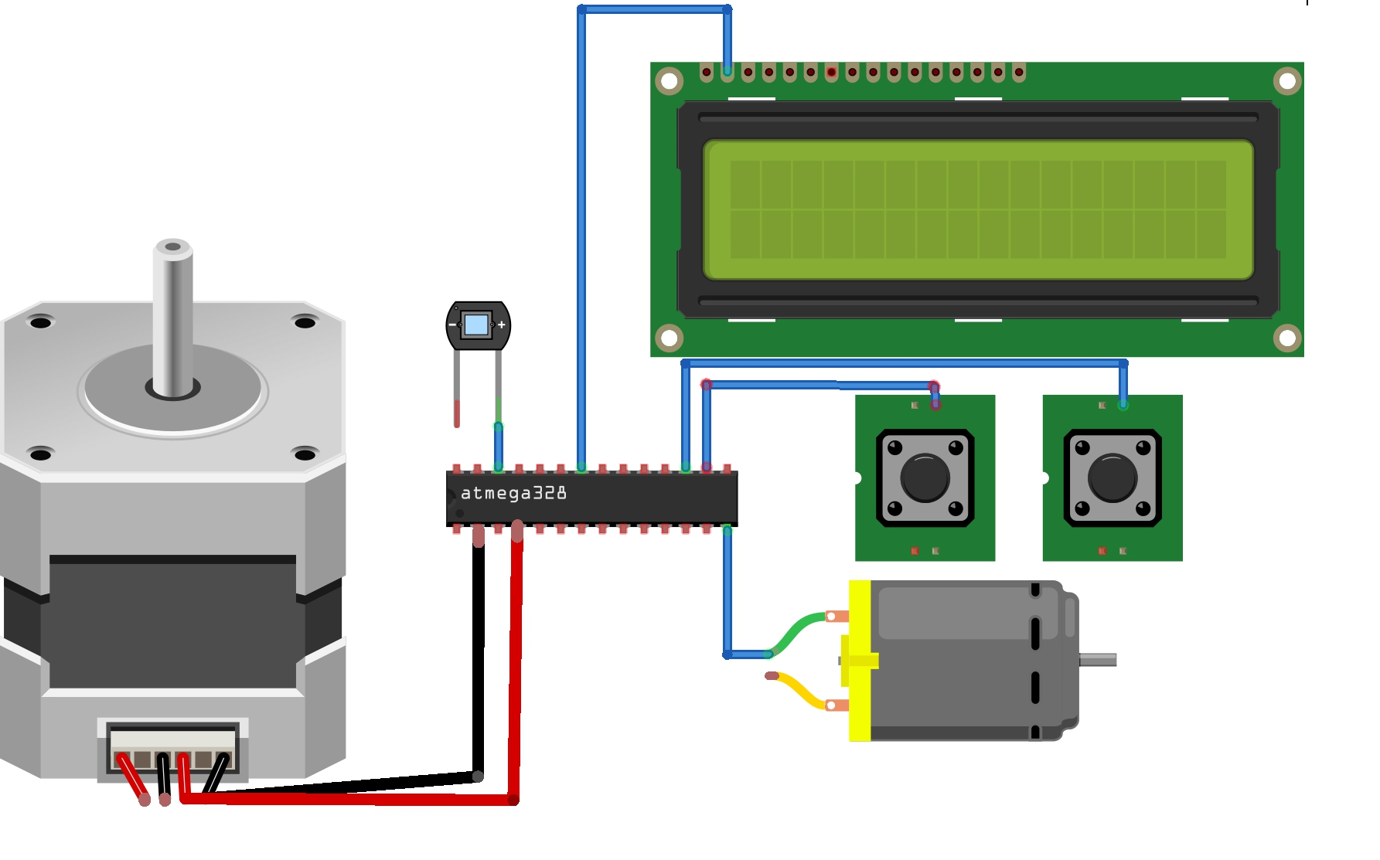

Front View
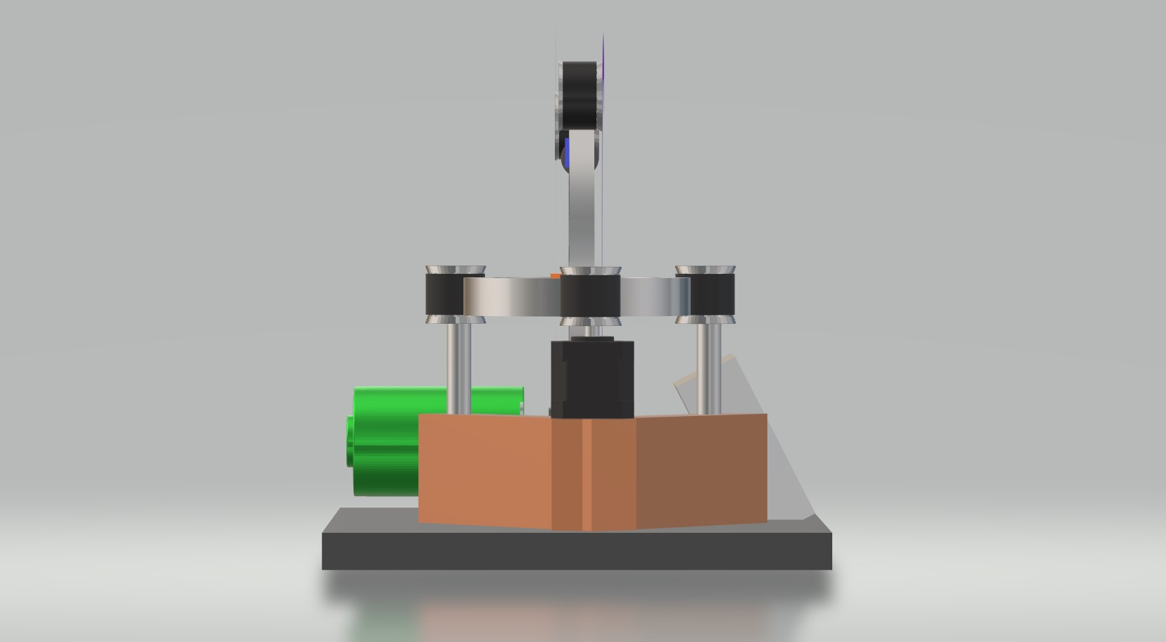
Side View
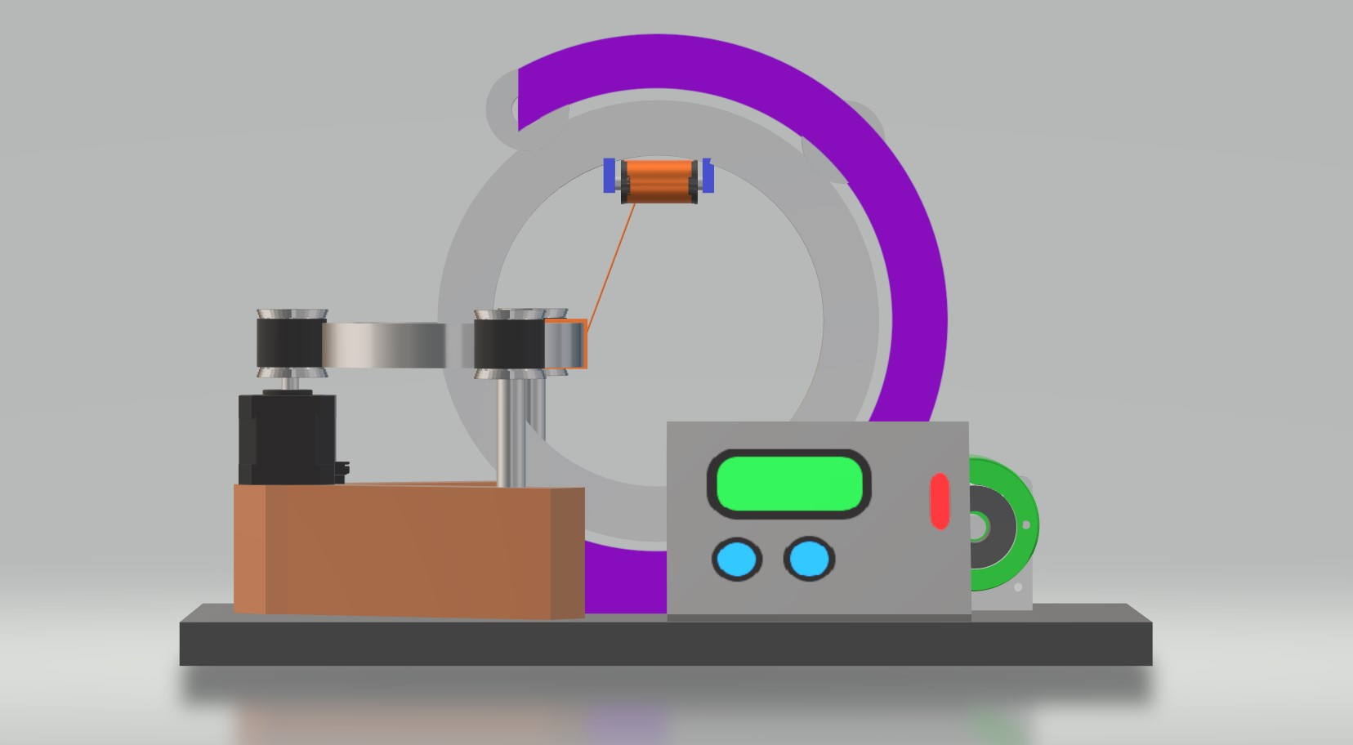

3D View
